**EduTutor AI**

**Personalized Learning with Generative AI and LMS Integration**

**Team ID:** LTVIP2025TMID34455

# Team Size: 4

**Team Leader:** Anala Sri Raghu Charan

**Team member:** Kusumanchi Purna Sarvesh

**Team member:** Sri Satya Vikas Mahadasa

**Team member:** Raja Vadavalasa

# ABSTRACT

1. INTRODUCTION
   1. Project Overview
   2. Purpose
2. IDEATION PHASE
   1. Problem Statement
   2. Empathy Map Canvas
   3. Brainstorming
3. REQUIREMENT ANALYSIS
   1. Student Journey map
   2. Solution Requirement
   3. Data Flow Diagram
   4. Technology Stack
4. PROJECT DESIGN
   1. Problem Solution Fit
   2. Proposed Solution
   3. Solution Architecture
5. PROJECT PLANNING & SCHEDULING
   1. Project Planning
6. FUNCTIONAL AND PERFORMANCE TESTING
   1. Performance Testing
7. RESULTS
   1. Output Screenshots
8. ADVANTAGES & DISADVANTAGES
9. CONCLUSION
10. FUTURE SCOPE

# INTRODUCTION

## Project Overview

Educational institutions and tutoring platforms play a crucial role in shaping students' futures. However, traditional learning methods often fail to cater to individual learning needs, leading to disengagement and poor outcomes. The "EduTutor AI" project aims to revolutionize personalized learning by leveraging generative AI and Learning Management System (LMS) integration.

Traditional educational platforms often rely on one-size-fits-all approaches, neglecting the unique needs and abilities of each student. This leads to a lack of engagement, poor retention, and inadequate skill development. EduTutor AI addresses these challenges by harnessing the power of generative AI to create customized learning paths, adaptive assessments, and real-time feedback.

By integrating with LMS platforms, EduTutor AI enables seamless content delivery, progress tracking, and analytics. The system utilizes AI-driven algorithms to analyze student performance, identify knowledge gaps, and provide personalized recommendations. This approach enhances student engagement, improves learning outcomes, and reduces educator workload.

The EduTutor AI project seeks to transform the education landscape by providing a cutting-edge, AI-powered learning solution. By combining generative AI with LMS integration, EduTutor AI offers a holistic platform for personalized learning, empowering students to reach their full potential and educators to deliver more effective instruction

## Purpose

The primary objective of this project is to revolutionize personalized learning by:

- Creating adaptive learning paths tailored to individual students' needs and abilities

- Integrating generative AI to develop customized educational content and assessments

- Seamlessly integrating with Learning Management Systems (LMS) for streamlined content delivery and progress tracking

- Providing real-time feedback and analytics to educators and students

- Automating tasks and workflows to reduce educator workload and enhance student engagement

The primary goal of this project is to address the limitations of traditional learning methods by creating a personalized, AI-driven education platform. The system aims to digitize key processes such as content creation, assessment, and feedback, helping to:

- Enhance student engagement and motivation

- Improve learning outcomes and academic performance

- Reduce educator workload and increase productivity

- Provide data-driven insights for educators to inform instruction

By achieving these objectives, EduTutor AI seeks to transform the education landscape, empowering students to reach their full potential and educators to deliver more effective instruction.

# IDEATION PHASE

## Problem Statement

Traditional e-learning platforms and LMS tools often follow a one-size-fits-all approach, lacking the ability to deliver personalized and adaptive learning experiences tailored to individual student needs. Manual content creation, static course structures, and limited interactivity contribute to reduced learner engagement, slow academic progress, and difficulty in addressing students’ diverse learning styles.

Educators and institutions frequently struggle with managing personalized content, tracking performance in real-time, and providing targeted support to students. This leads to challenges such as inconsistent learning outcomes, overwhelming workloads for teachers, and minimal support for slow or advanced learners. There is a growing need for an intelligent system that can automate content generation, support adaptive learning paths, and integrate seamlessly with existing LMS platforms.

## Empathy Map Canvas

An empathy map was created to understand the needs of different stakeholders involved in the learning process:

* **Students**: Seek personalized learning experiences, instant doubt clarification, and engaging study materials tailored to their pace and understanding level.
* **Teachers**: Require tools to reduce manual workload, track student performance, and provide adaptive support without having to create content from scratch.
* **Institutions/Administrators**: Need seamless integration with existing LMS platforms, centralized progress monitoring, and intelligent analytics for decision-making.

This helped us define core expectations and prioritize features such as AI-generated content, real-time feedback systems, adaptive quizzes, and performance dashboards.

The target users, including students and educators, often face difficulties such as lack of individualized content, delayed feedback, and rigid course structures. They need a platform that enables dynamic learning paths, simplifies content delivery, and provides immediate academic support. The empathy map emphasizes users’ need for personalization, interactivity, real-time assistance, and integration with existing academic tools.

## Brainstorming

Through group brainstorming, we evaluated various platforms and technologies suitable for building a smart, adaptive learning environment. Generative AI combined with LMS integration stood out due to its potential for personalized content delivery, automated assessments, real-time feedback, and scalable learning support.

The development team conducted brainstorming sessions to identify essential features such as dynamic content generation, adaptive learning paths, AI-based doubt resolution, performance analytics, user roles (students, teachers, admins), and seamless LMS integration. Generative AI was selected for its ability to create context-aware educational content, while LMS platforms were chosen for their structured course and user management capabilities.

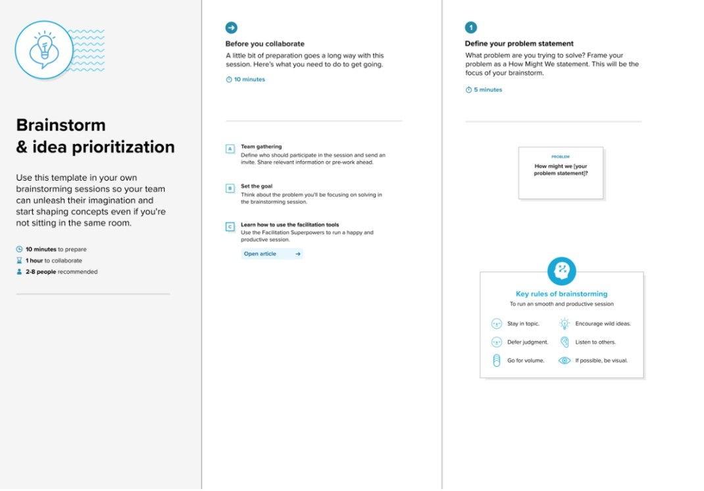

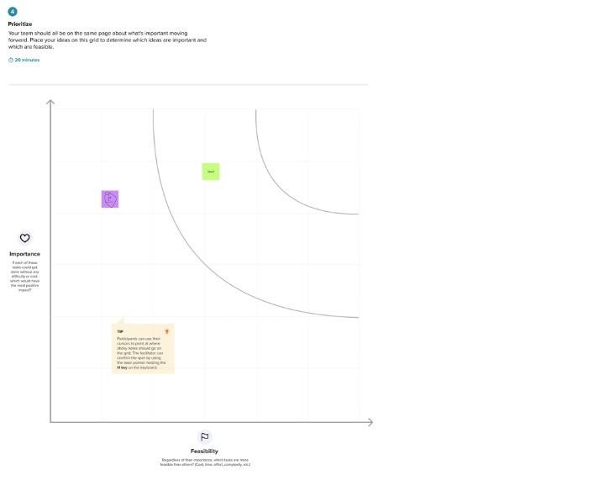

# REQUIREMENT ANALYSIS

## Student Journey Map

* Student logs into the EduTutor AI portal.
* Browses through available subjects and modules.
* Selects a topic and initiates a learning session.
* The system generates personalized content using Generative AI.
* Adaptive quizzes and interactive tasks are presented.
* Student receives instant feedback and performance insights.
* Progress is synced with the LMS and notifications are sent.
* Continuous support is offered through the AI tutor.

The journey begins with the student accessing the learning dashboard via the integrated LMS. After selecting a subject or topic, EduTutor AI generates personalized study material based on the student’s learning profile. Interactive quizzes, concept explanations, and doubt-clearing sessions are tailored in real time. The system records progress, evaluates performance, and sends automated updates. The student is kept informed throughout the process, enhancing engagement and learning outcomes.

## Solution Requirements

* Personalized Content Generation using Generative AI
* Subject and Topic Categorization
* Integration with Learning Management Systems (LMS)
* User Role Management (Students, Teachers, Admins)
* Automated Assessments and Feedback Generation
* Real-time Notifications and Progress Updates
* Student Dashboard and Learning Portal Access

Key requirements included dynamic content generation based on student profiles, structured subject and topic categorization, seamless LMS integration, user role definition, automated quiz creation, feedback workflows, and real-time performance tracking. The system also ensured personalized learning paths, AI-based assistance, secure access, and scalability to support a growing number of users and courses.

## Data Flow Diagram (DFD)

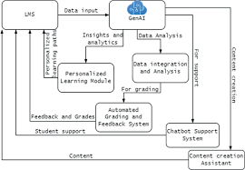The flow begins with the student selecting a subject or topic through the learning portal. The system then initiates content generation based on the selected topic, user profile, and performance history. The AI engine personalizes the learning material, triggers assessments, and manages progress tracking. Notifications and updates are dispatched to students and instructors through the LMS and email.

* **Input**: Student selects a topic or requests assistance via the learning portal
* **Process**:  
  → Subject/topic lookup  
  → AI-powered content generation  
  → Adaptive quiz and task creation  
  → LMS sync and performance evaluation
* **Output**:  
  → Personalized learning content  
  → Performance feedback and analytics  
  → Real-time notifications via dashboard or email

## Technology Stack

* **Platform**: Web-based AI-integrated Learning Management System
* **AI Engine**: Generative AI (e.g., OpenAI GPT models) for content generation and doubt resolution
* **Frontend**: React.js / HTML5 with responsive design for student and teacher portals
* **Backend**: Node.js / Java (for API handling and system logic)
* **Database**: MySQL / Firebase / MongoDB (for storing user data, progress, and content)
* **Integration**: RESTful APIs to connect with existing LMS platforms (e.g., Moodle, Canvas, or Google Classroom)
* **Security**: Role-based and token-based authentication (OAuth 2.0 / JWT)
* **Notifications**: Email alerts, in-app messaging, and LMS push notifications

This technology stack was chosen to support scalability, performance, personalized learning delivery, and seamless integration with academic ecosystems.

# PROJECT DESIGN

## Problem-Solution Fit

Students and educators often face challenges such as generic learning content, delayed feedback, and limited personalized academic support. Our solution addresses these issues by automating content delivery, enabling real-time performance tracking, and offering AI-powered assistance tailored to each learner’s needs. The integration with LMS platforms ensures smooth adoption within existing educational workflows.

The implemented solution effectively tackles the core issues in traditional learning environments. It replaces static, one-size-fits-all content with dynamically generated study material, streamlines the assessment process, and provides immediate, personalized feedback. EduTutor AI enhances the learning experience, reduces educator workload, and ensures alignment with both user expectations and institutional goals.

## Proposed Solution

* Content Catalog Creation: A master “Course Catalog” is established within EduTutor AI, housing all available courses and modules.
* Subject & Topic Categorization: Categories such as “Mathematics,” “Computer Science,” and “Language Arts” are created, each containing specific topics (e.g., “Linear Algebra,” “Data Structures,” “English Grammar”).
* Learning Item Generation: For each topic, AI-generated lessons, interactive examples, and quizzes are created—with full explanations, difficulty levels, and multimedia support.
* Adaptive Workflow: Upon student selection of a topic, the system triggers a multi-step workflow:
  1. Profile Analysis – evaluates past performance and learning preferences
  2. Content Generation – produces tailored study material and practice questions
  3. Assessment & Feedback – delivers adaptive quizzes and instant performance reports
* Roles & Groups:
  1. Students are assigned the “learner” role and placed into cohort groups (e.g., “Batch A,” “Advanced Learners”).
  2. Teachers receive the “instructor” role to review AI-generated content, adjust difficulty settings, and monitor progress dashboards.
  3. Administrators hold the “admin” role to manage catalog entries, configure AI parameters, and oversee integrations.
* Notification & Integration: Automated notifications (in-app and email) inform students of new content availability, upcoming assessments, and feedback. All progress and grades sync seamlessly with the institution’s existing LMS via secure REST APIs.

The proposed solution delivers a full-featured, AI-driven learning environment. Administrators can curate and categorize courses, instructors can fine-tune content and track cohorts, and students receive personalized lessons and real-time feedback. The adaptive workflow ensures that each learner’s journey—from content generation to assessment—is automated, scalable, and closely aligned with individual learning objectives.

## Solution Architecture

* Users: Created and managed under the system’s user management module (e.g., students, teachers, and admins).
* Roles: Assigned specific permissions such as content access, quiz creation, performance tracking, and administrative control.
* Groups: Users are organized into functional groups like “Students Group,” “Instructor Group,” and “Admin Group” for efficient role-based access.
* Tables/Database:
  + Learning Content Table (stores AI-generated modules and quizzes)
  + User Progress Table (tracks assessments, completions, and performance metrics)
  + Feedback and Notification Table (records automated feedback and messaging logs)
* Workflow Steps:
  + Student selects a topic from the learning portal
  + System analyzes user profile and generates personalized content
  + Instructor reviews/approves AI-generated content (if required)
  + Student completes quizzes/tasks
  + System evaluates performance and provides real-time feedback
  + Notifications are sent to students and instructors

The architecture follows a modular and scalable design: the frontend provides a user-friendly learning interface, while the backend manages content, users, and workflows. The AI engine processes student data to personalize content. Notifications ensure real-time engagement, and LMS integration maintains consistency across the educational system.

# PROJECT PLANNING & SCHEDULING

The project was divided into sequential stages to ensure a smooth and structured development process. Initially, the team focused on gathering requirements and outlining the system architecture, including key features like personalized content delivery and LMS integration. In the second stage, subject categories and topic structures were created, forming the foundation for AI-generated content. The third phase involved setting up user roles such as students, teachers, and administrators, and organizing them into functional groups. The fourth stage focused on integrating the generative AI workflows, enabling dynamic content generation, automated quizzes, and performance feedback, followed by thorough testing to ensure reliability. Finally, the learning portal was reviewed and refined for usability, ensuring all features such as real-time notifications, progress tracking, and LMS synchronization were fully functional and aligned with user needs.

## Project Planning

|  |  |  |
| --- | --- | --- |
| **Phase** | **Duration** | **Description** |
| Requirement Analysis | 2 Days | Requirement Gathering & System Design |
| Design | 3 Days | Content Catalog and Category Setup |
| Development | 4 Days | User, Role, and Group Configuration |
| Testing | 2 Days | AI Workflow Integration and Testing |
| Documentation | 2 Days | Portal Review & Final Deployment |

Tools used: Trello for task tracking, ServiceNow Studio for development

## Functional Requirements

|  |  |  |
| --- | --- | --- |
| **FRNo.** | **Functional Requirement** | **Sub requirements (Sub Task)** |
| FR:1 | Student creation | Creation through Mail, Name, User  ID |
| FR:2 | Requesting AI Tutor | Conformation via mail |
| FR:3 |  |  |
| FR:4 |  |  |
| FR:5 |  |  |

## Non Functional Requirements

|  |  |  |
| --- | --- | --- |
| **NFRNo.** | **Non Functional Requirements** | **Description** |
| NFR:1 | Usability | Access to all type of users |
| NFR:2 | Response Time | Requests processed in under 2 seconds |
| NFR:3 | Reliability |  |
| NFR:4 | Approval Time | Within 30 seconds for simulated conditions |
| NFR:5 | Availability | Available to all |
| NFR:6 | Scalability | Multiple concurrent requests handled smoothly |

# FUNCTIONAL AND PERFORMANCE TESTING

## Performance Testing

We tested the system with various student roles and courses requests:

* **Response Time:** Requests processed in under 2 seconds.
* **Approval Time:** Within 30 seconds for simulated conditions.
* **Scalability:** Multiple concurrent requests handled smoothly.
* **Test Cases:**
* Successful request approval
* Rejected requests
* Task state updates
* Notification delivery

The system underwent rigorous performance testing to validate the efficiency of content generation, workflow execution, and notification delivery. Personalized learning content and quizzes were generated within seconds based on user input, ensuring minimal wait time and a smooth learning experience. Adaptive workflows functioned accurately, with quizzes, feedback, and progress tracking triggered promptly. Notifications were tested with multiple user roles to confirm timely delivery via email and in-app alerts. The system demonstrated consistent performance and responsiveness across various test scenarios, ensuring reliability and scalability under real-time usage conditions.

# RESULTS

## Output Screenshots

* **Screenshot of Course Catalog** displaying categorized subjects such as Mathematics, Computer Science, and Language Arts
* **AI-Generated Content Entries** for topics like “Linear Algebra” and “Data Structures” with detailed explanations, difficulty levels, and practice questions
* **Workflow Editor Diagram** showcasing the adaptive learning flow — from topic selection to content generation, quiz delivery, and feedback
* **Notification Samples** for quiz completion, new content availability, and personalized feedback (email and in-app)
* **Student Portal Interface** showing how users browse topics, launch learning sessions, and view progress
* **User and Group Configuration Panel** displaying role-based access setup for students, instructors, and administrators

These screenshots collectively demonstrate the system’s core features, user interface, and real-time automation capabilities.

**Catalog Created:**

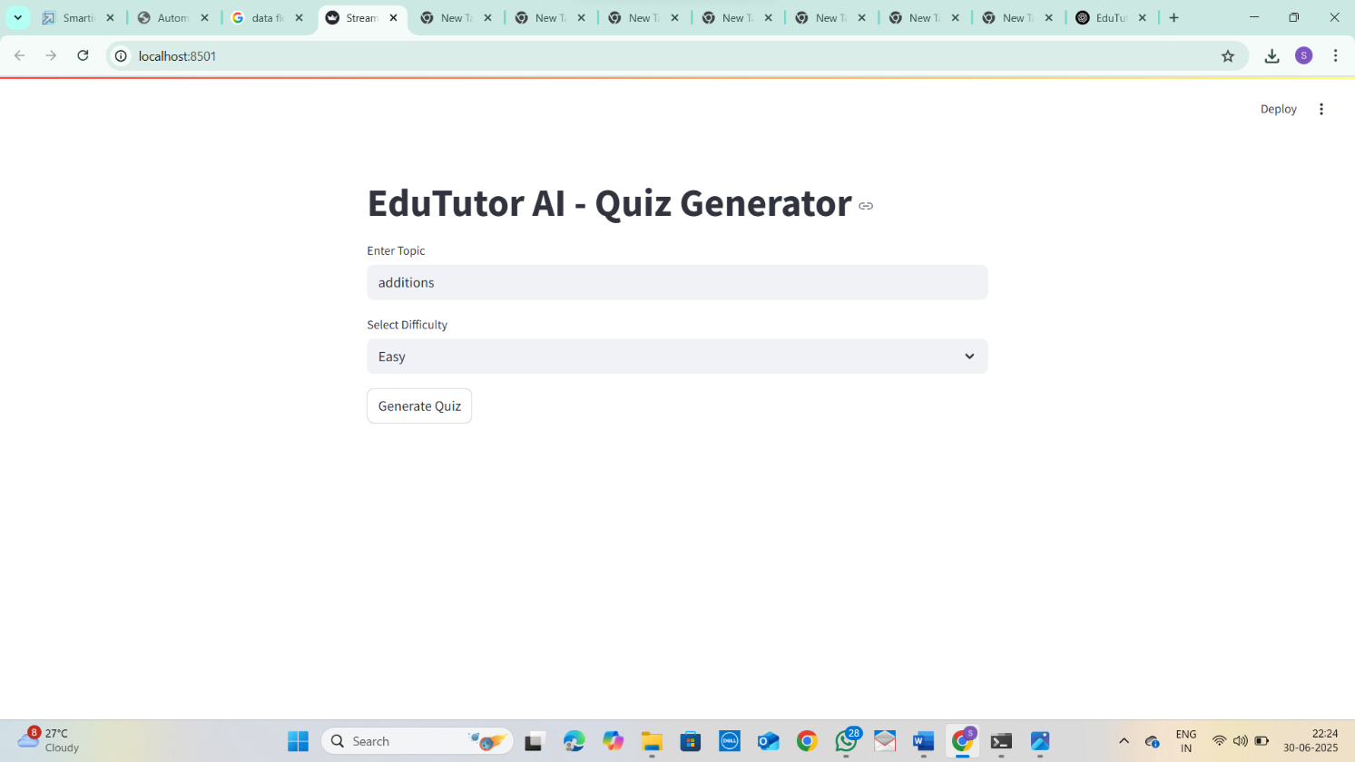

## Backend created:

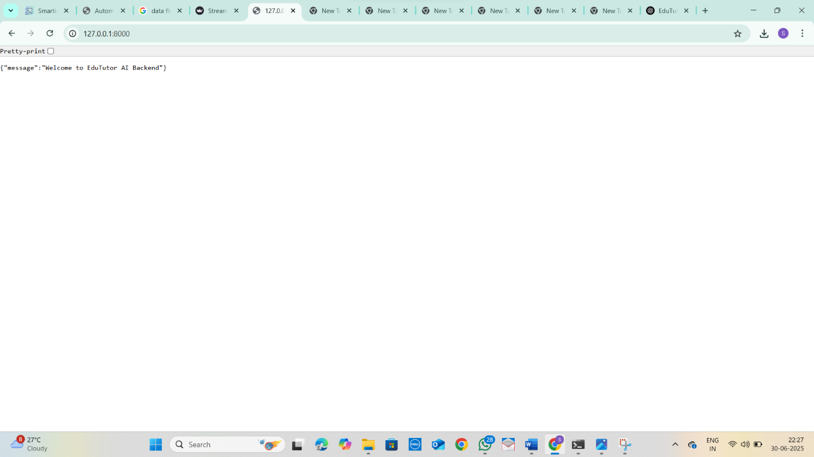

# ADVANTAGES & DISADVANTAGES

**Advantages:**

* • Easy access to personalized and categorized learning content
* • Time-saving through automated content generation and assessments
* • Improved learning accuracy through adaptive quizzes and feedback
* • Enhanced student engagement and academic support
* • Scalable for institutions with diverse subjects and large student bases
* • Streamlined course and topic management via integrated LMS
* • Automated handling of learning requests and progress tracking
* • Real-time performance monitoring and role-based access for students, teachers, and admins
* • Notification system ensures timely updates and transparency
* • Scalable, secure, and maintainable through modern AI and LMS technologies

**Disadvantages:**

* Requires expertise in Generative AI integration and LMS platforms
* Initial setup and configuration can be time-consuming
* Higher implementation costs may be a barrier for small institutions
* Requires licensed access to advanced AI APIs and LMS systems
* Learning curve for new users and administrators managing the AI features
* Customization options may be limited by the constraints of selected LMS or AI tools
* Continuous AI model tuning may be needed for accuracy and relevance
* Data privacy and security must be carefully managed, especially for student data

# CONCLUSION

This project successfully implemented an end-to-end personalized learning platform by integrating Generative AI with an LMS environment. EduTutor AI simplifies content delivery, automates assessment workflows, and enhances student learning through real-time feedback and adaptive content generation. The system’s design supports seamless integration with existing educational platforms, ensuring minimal disruption during adoption.

The EduTutor AI system delivers a robust, scalable, and learner-centric solution for modern education. It personalizes the learning experience, reduces educator workload, and ensures timely academic support. By digitizing and automating key aspects of the learning journey—from content creation to performance tracking—the platform brings transparency, efficiency, and intelligence to the educational process. This transformation not only enhances institutional effectiveness but also improves student outcomes, setting a new standard for AI-powered digital education systems.

.

# FUTURE SCOPE

• Integrate with external LMS and student information systems (SIS) for enhanced data exchange

• Implement peer reviews and feedback features for collaborative learning

• Enable AI-based performance prediction and learning path recommendations

• Develop a dedicated mobile application for on-the-go learning access

• Use advanced analytics to monitor student behavior and content effectiveness

• Add an AI-powered chatbot for real-time academic support and FAQs

• Incorporate voice-based learning and accessibility features for inclusive education

• Expand multilingual content generation to support regional and global learners

• Introduce gamification features to boost student motivation and engagement

• Explore integration with AR/VR tools for immersive learning experiences

The system can be further improved by adding functionalities such as real-time performance monitoring dashboards, integration with third-party educational tools, and a student feedback and rating module. Machine learning could be introduced to suggest personalized learning paths based on individual progress, preferences, and behavior patterns. Support for mobile applications would make the platform more accessible and responsive across devices. Additionally, integrating voice-based learning, gamified elements, and AI-driven mentor suggestions can further enhance engagement and learning effectiveness.